

User Manual

Intended for host clients

Checkpoint attendance system

2017

Table Of Contents

Table Of Contents 2

1 Introduction 3

1.1 IMPORTANT! A Quick Note about the CheckPoint Lexicon 4

1.2 About the User Manual 4

1.3 Download reading terminal installer and user manual 4

2 Getting started 6

3 Host Operations 7

3.1 Appointments 8

3.1.1 View Courses 9

3.1.2 Create Appointment 9

3.1.3 Manage appointment 10

3.1.4 Add selected appointment to course 11

3.2 Manage Attendance 12

3.2.1 Manage Attendance For Courses 12

3.2.2 Manage Attendance For Appointments 14

3.3 Courses 16

3.3.1 View Appointments 17

3.3.2 Create Course 17

3.3.3 Manage Course 18

3.4 View Completed Appointments & Attendance History 21

3.4.1 Appointment Attendance Records 23

3.5 Alter profile 23

3.6 Log out 24

4 Troubleshooting 25

5 Contact Us 26

# Introduction

Congratulation on your first CheckPoint host account!

As a host in the CheckPoint attendance system you will be able to easily create and maintain appointments and courses which users can apply to. You can manage attendance requests from users and track attendance history on your appointments!

## IMPORTANT! A Quick Note about the CheckPoint Lexicon

CheckPoint is a flexible application that can be used for all types of events, meetings and rendezvous. This might include educational courses and lectures, work seminars, leisure activities or any other planned event where people wish to get together. With that in mind, it is important to recognize that within the CheckPoint lexicon an ‘**appointment**’ is the general term used to refer to any independent event that occurs only once. Meanwhile, a ‘**course**’ is the term used to describe a group of events/appointments.

## About the User Manual

This user manual covers all features a host account entails in the CheckPoint web application.

The scope of this user manual does not cover the CheckPoint Reading Terminal software which is used to log attendance on appointments and courses. To get started with logging attendance on your appointments please go to chapter 1.3

## Download reading terminal installer and user manual

The CheckPoint Reading Terminal installer which also includes the user manual for the reading terminal can be downloaded on the “Download” page of the web page shown in *Figure 1‑2*.

By clicking the calendar icon on the navigation bar as illustrated in *Figure 1‑1*,you will access the “Download” web page shown in *Figure 1‑2* .

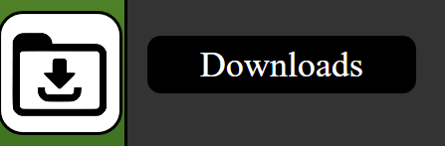

Figure 1‑1: Downloads icon

By clicking the “Download reading terminal installer” you will download the installer containing the user manual for the reading terminal.

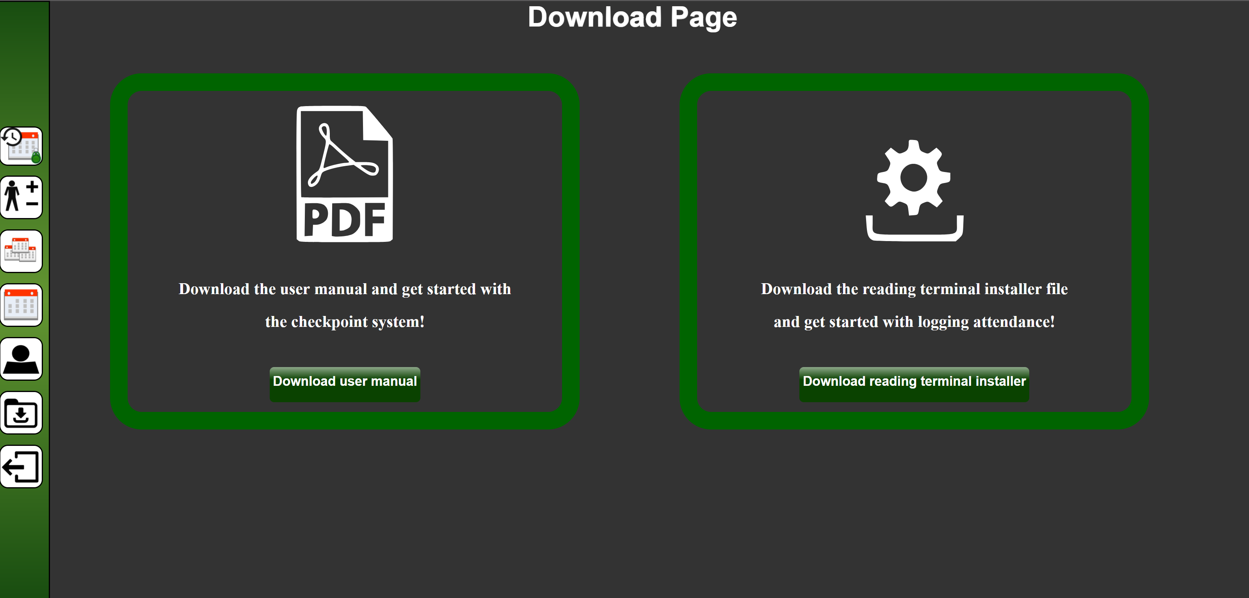

Figure 1‑2: Download page

When the installer for the reading terminal is downloaded, you will need to install the application to get access to the reading terminal user manual. The user manual will be placed on your desktop after installation is completed.

# Getting started

Simply navigate to our homepage (www.checkpoint.azurewebsites.net) and register an account as a new host by clicking on the “Get Started With CheckPoint” button as indicated below in Figure 2‑1. The requested address does not need to be your home address – you may choose the address where you would like us to deliver your reading terminal device.

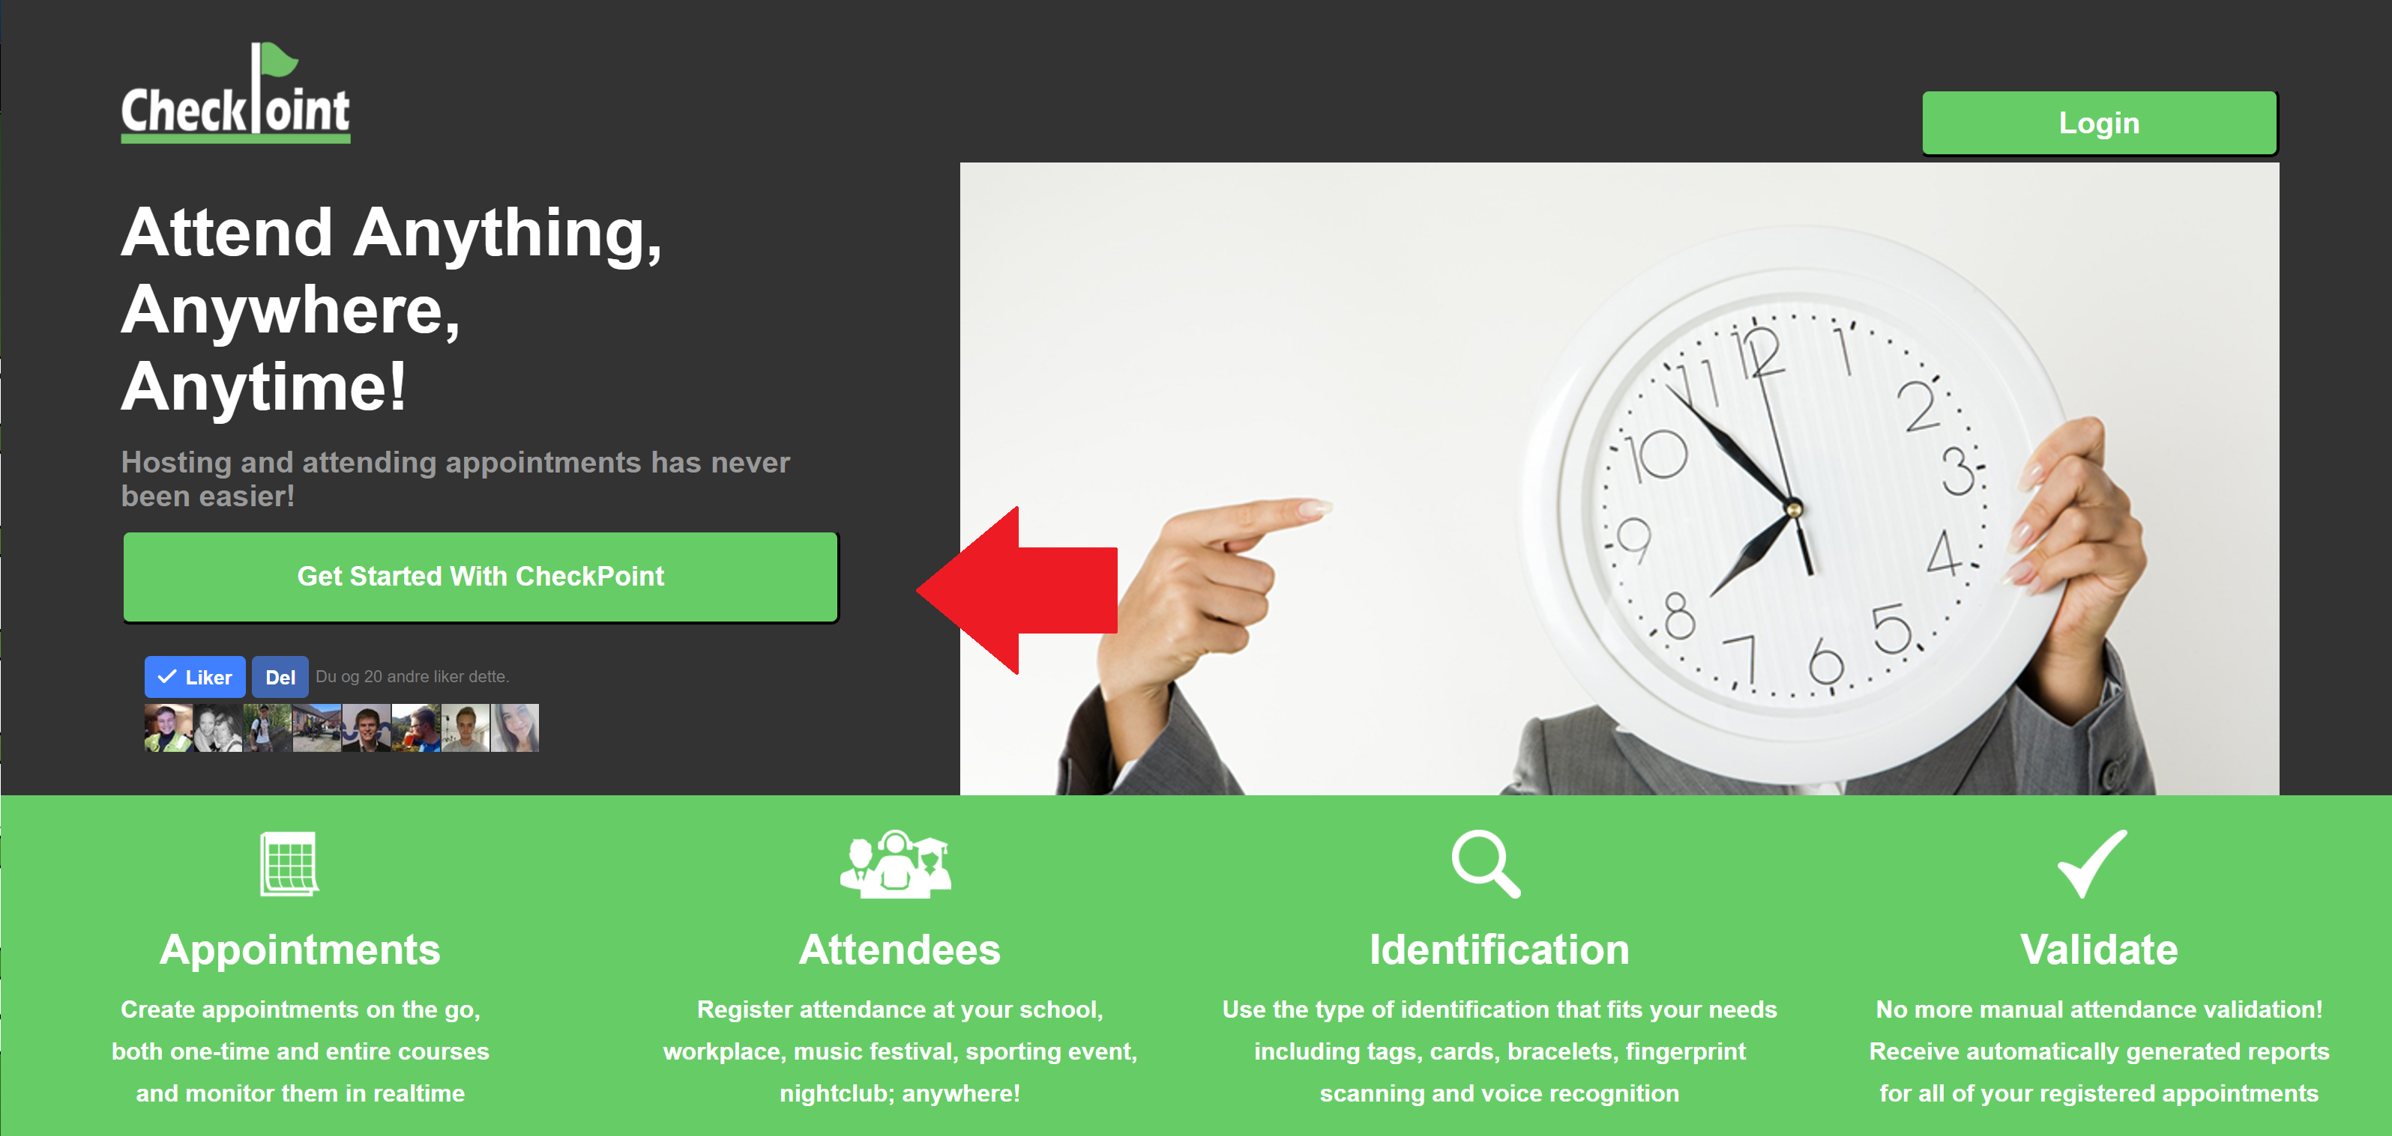

Figure 2‑1Register a new user account by clicking the ‘Get Started With CheckPoint’ button

Once your details have been confirmed and verified you can expect to receive your personal reading terminal device within 14 days.

In the meantime, you may log in and start exploring the CheckPoint web application as a host.

# Host Operations

Once you have logged in as a host through the CheckPoint main web page, you will be met by the *Appointments* page which is illustrated in *Figure 3‑1*.

On the left side of the web page you will find the navigation bar, from here you can access all the main host features which are explained in the following sub chapters.

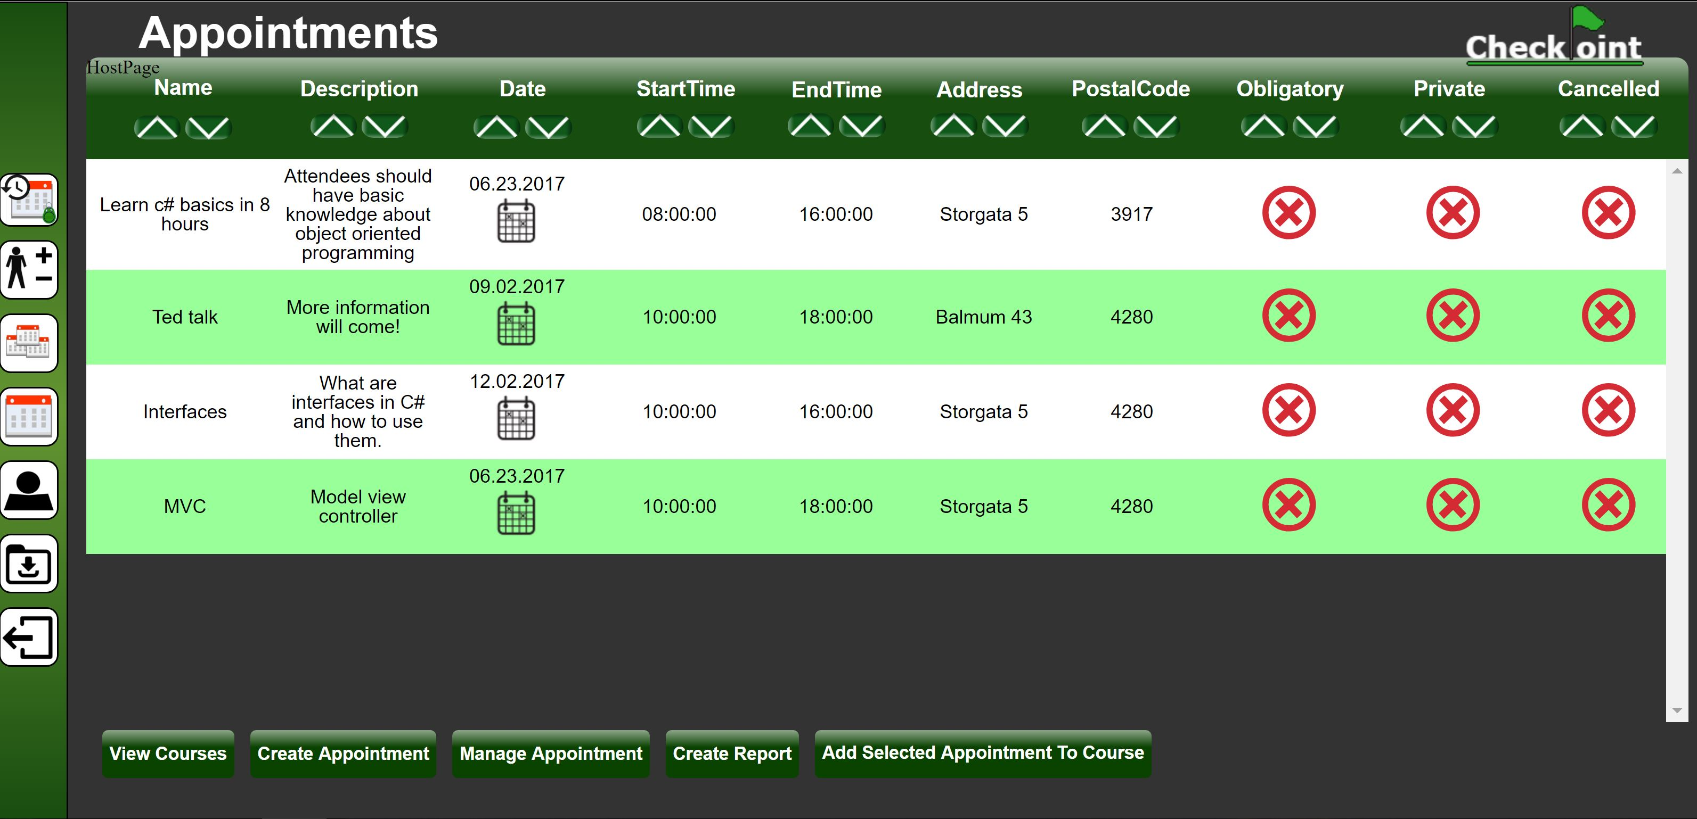

Figure 3‑1: My appointments web page with the navigation bar on the left side

## Appointments

By clicking the calendar icon on the navigation bar as illustrated in Figure 3‑2, you will access the “My appointments” web page.

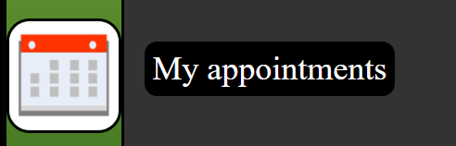

Figure 3‑2: Calendar icon on the navigation bar.

On this web page, which is illustrated in Figure 3‑4, you will get a detailed table view of all your appointments. The appointments can be sorted by each column in the table, either by clicking the sort ascending button or sort descending button in the column shown in Figure 3‑3.



Figure 3‑3: Sorting buttons, ascending (left) and descending (right).

You will also have the following options on the bottom of the web page illustrated in Figure 3‑4:

*3.1.1 View Courses*

*3.1.2 Create Appointment*

*3.1.3 Manage appointment*

*3.1.4 Add selected appointment to course*

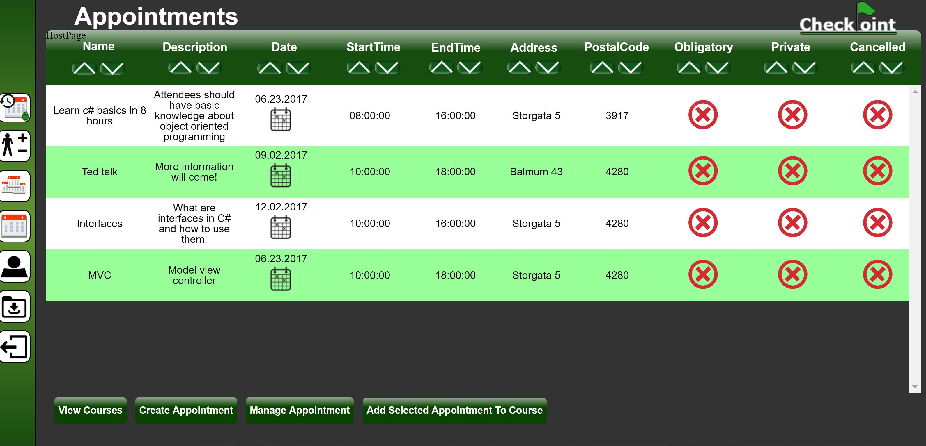

Figure 3‑4: My appointments web page

### View Courses

By clicking the “View Courses” button shown in *Figure 3‑4*. you will be redirected to the “My courses” web page which is described in chapter 3.3.

### Create Appointment

Create a new appointment by clicking the “Create Appointment” button.  
This will redirect you to a web page where you can fill in the details of the new appointment as illustrated in *Figure 3‑5*.

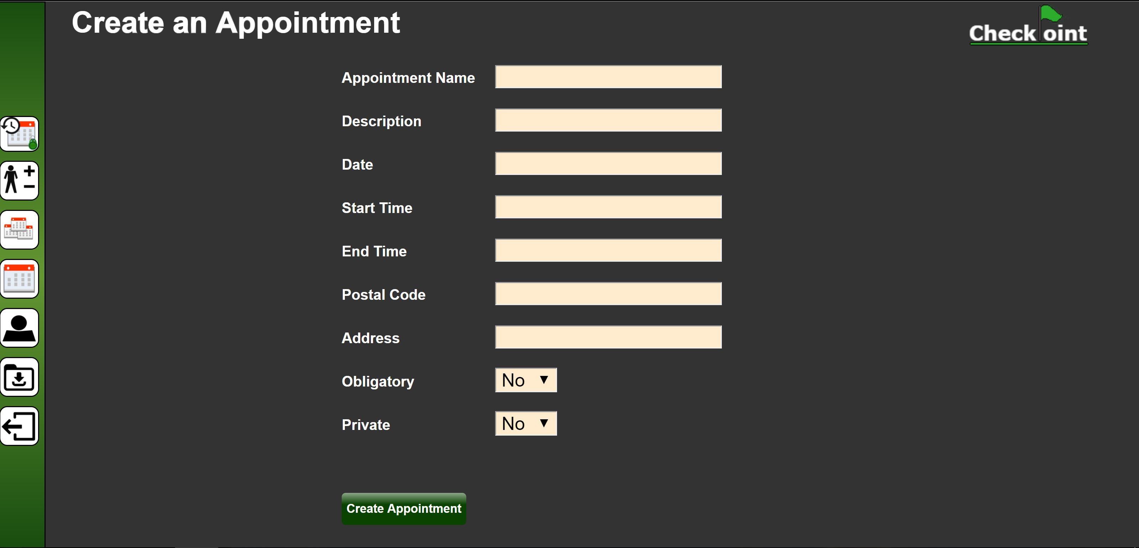

Figure 3‑5: Create appointment web page

When you create an appointment, you must choose if it should be:

* Obligatory, this will show users that it is an obligatory appointment.
* Private, only invited users can find and attend this appointment.
* Cancelled, this shows users if the appointment has been cancelled or not.

### Manage appointment

Manage an appointment by selecting an existing appointment from the list and clicking the “Manage appointment” button shown in *Figure 3‑4*. This will redirect you to a new web page as illustrated in *Figure 3‑6,* here you can edit the details of the selected appointment and click the “Update Appointment” button to save the changes.

By clicking the “Delete Appointment” button shown in *Figure 3‑6,* you will delete the appointment.

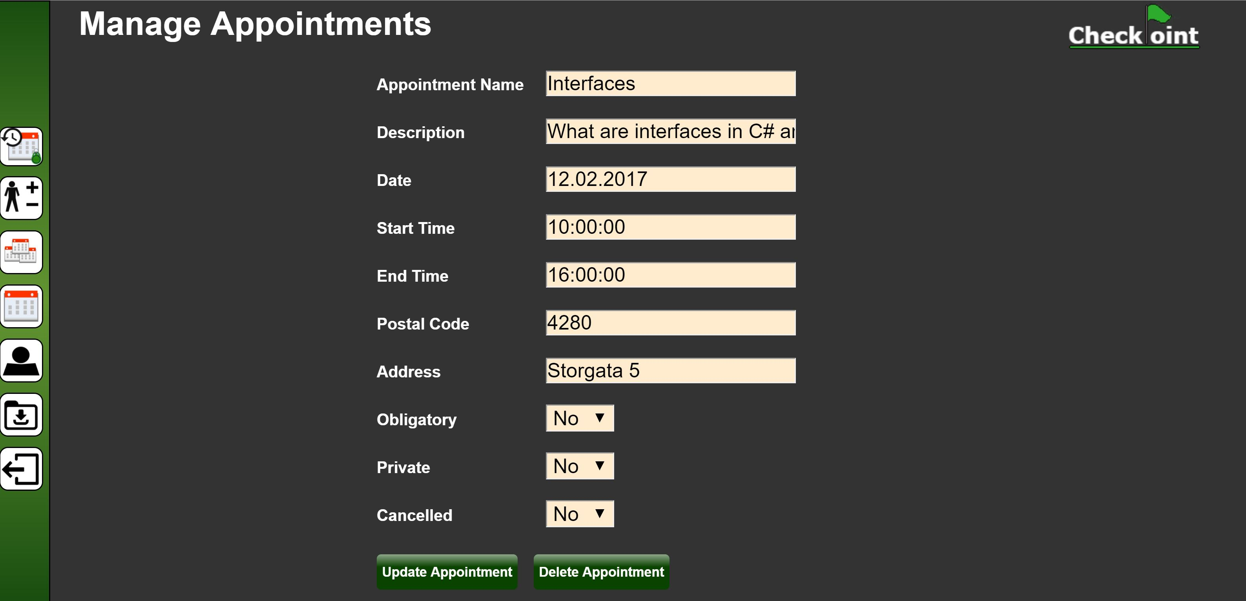

Figure 3‑6: Manage appointment Web Page

### Add selected appointment to course

Add an appointment to a course by selecting an existing appointment from the table and pressing the “Add Selected Appointment to Course” button shown in *Figure 3‑4*.

This will redirect you to a new web page with a list of all your current courses as illustrated in *Figure 3‑7*. Here you can choose which course the appointment will be added to and click the “Add Appointment To Selected Course” button.

After you have added the appointment to the course of your choosing, you will be redirected to the course management web page. This web page is explained in chapter *3.3.3 Manage Course .*

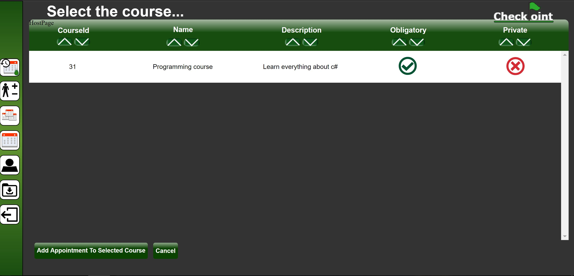

Figure 3‑7: Select course web page

## Manage Attendance

To access the manage attendance function, click the Manage Attendance icon on the navigation bar as illustrated in Figure 3‑13. This will redirect you to the “Manage Attendance For Courses” web page which is described in chapter 3.2.1*.*



Figure 3‑8: Manage attendance icon on the navigation bar

### Manage Attendance For Courses

On the “Manage Attendance For Courses” web page shown in *Figure 3‑9*, you will get a detailed table view of all your courses with active attendee requests. The courses can be sorted by each column in the table, either by clicking the sort ascending button or sort descending button in the column shown in *Figure 3‑3.*

By clicking the “Manage Attendance For Appointments” button shown in *Figure 3‑9* and *Figure 3‑10,* you will be redirected to the “Manage Attendance For Appointments” web page which is described in chapter 3.2.2.

By selecting a course in the table shown in *Figure 3‑9* a new table with the heading “attendee requests” will appears as shown in *Figure 3‑10.*

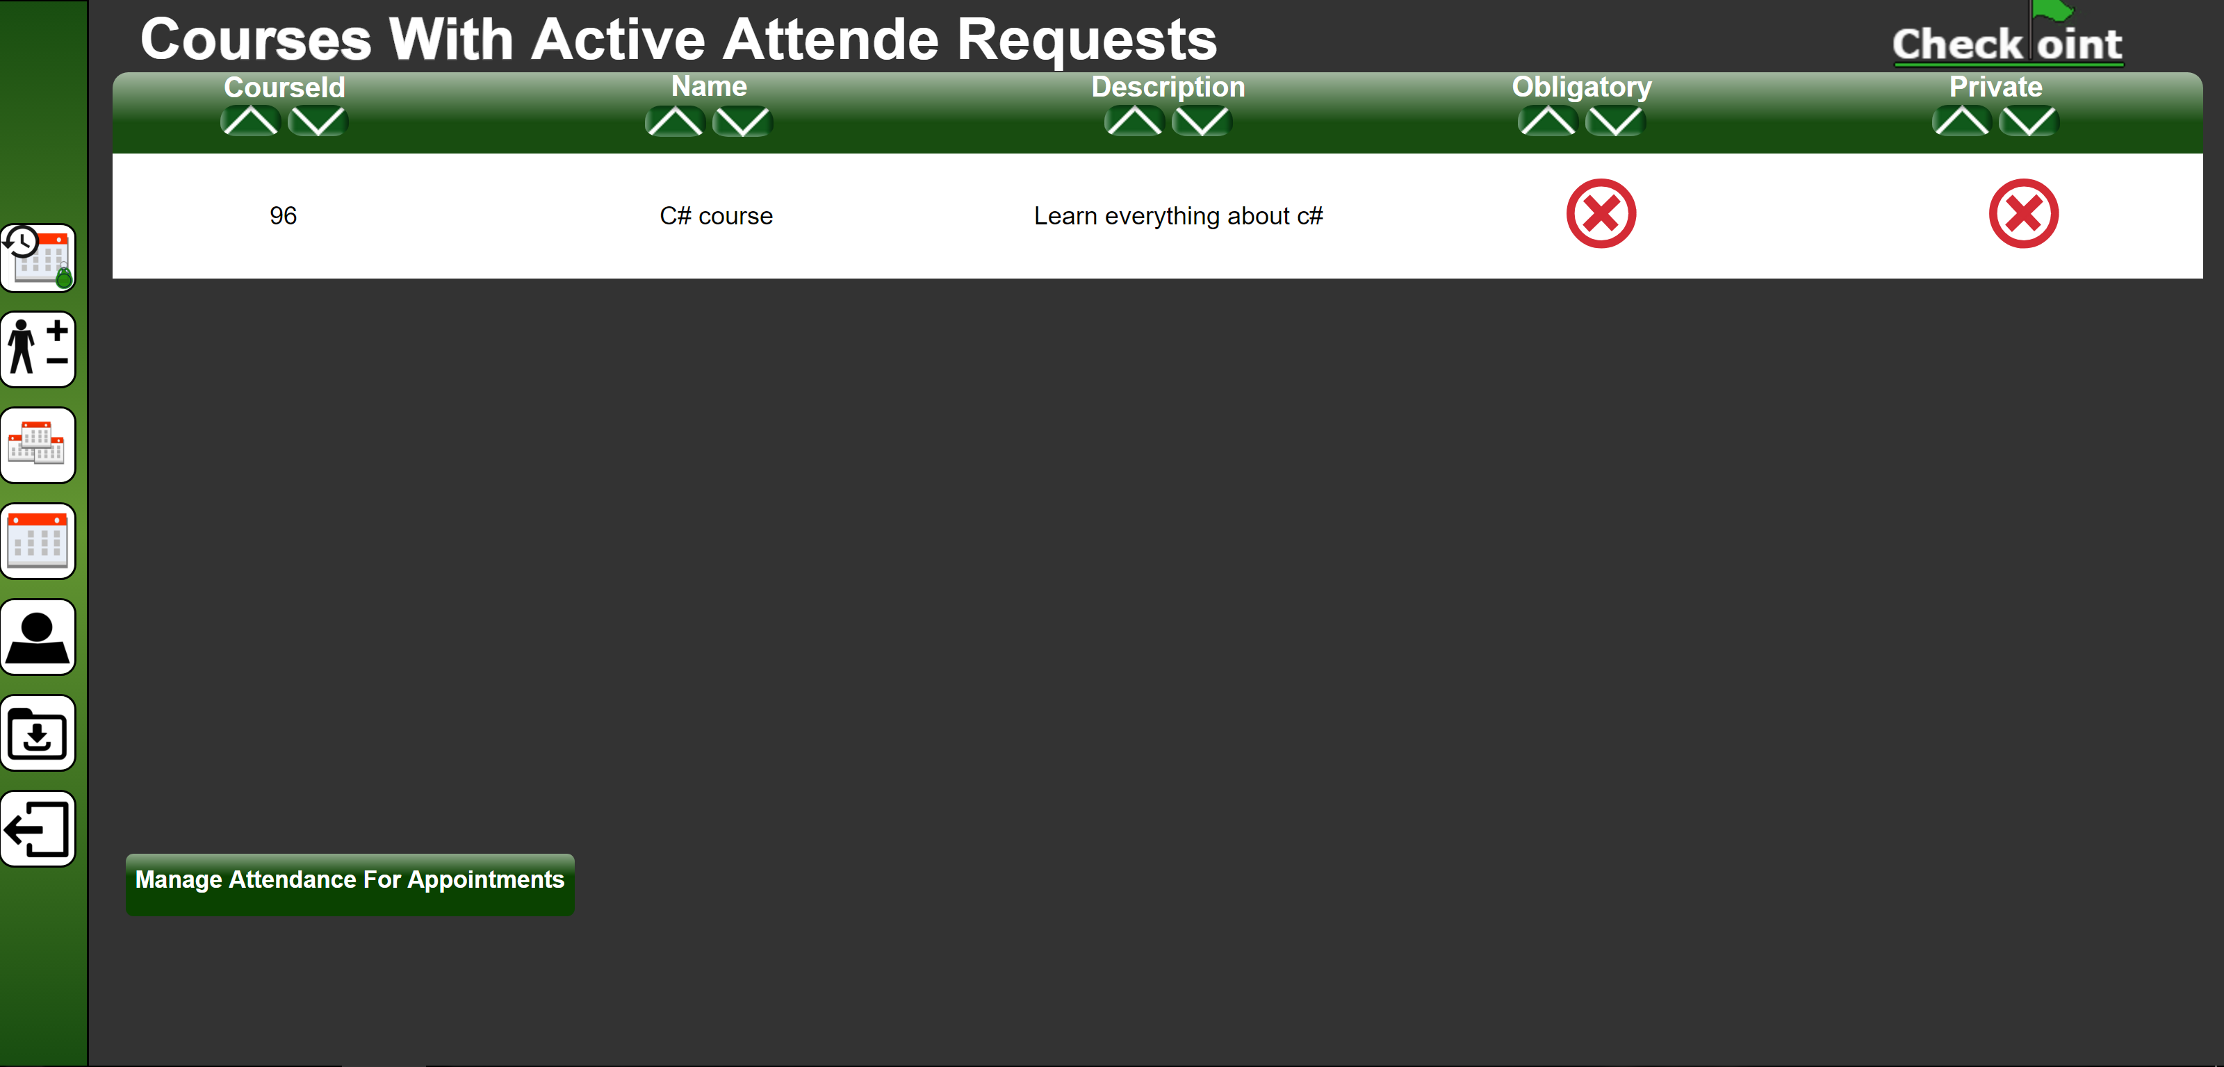

Figure 3‑9: Manage attendance for courses page

By selecting a user from the “Attendee Request” table shown in *Figure 3‑12* and clicking the “Accept Selected Attendee Request” button shown in *Figure 3‑12 ,* you will make the selected user a attendee for that course. Now the user can attend your appointments in the course!

By clicking the “Accept all Attendance Request For Selected Course” button shown in *Figure 3‑12 ,* you will make all the users in the “Attendee Requests” table attendees for the selected course. Now the users can attend your appointments in the course!

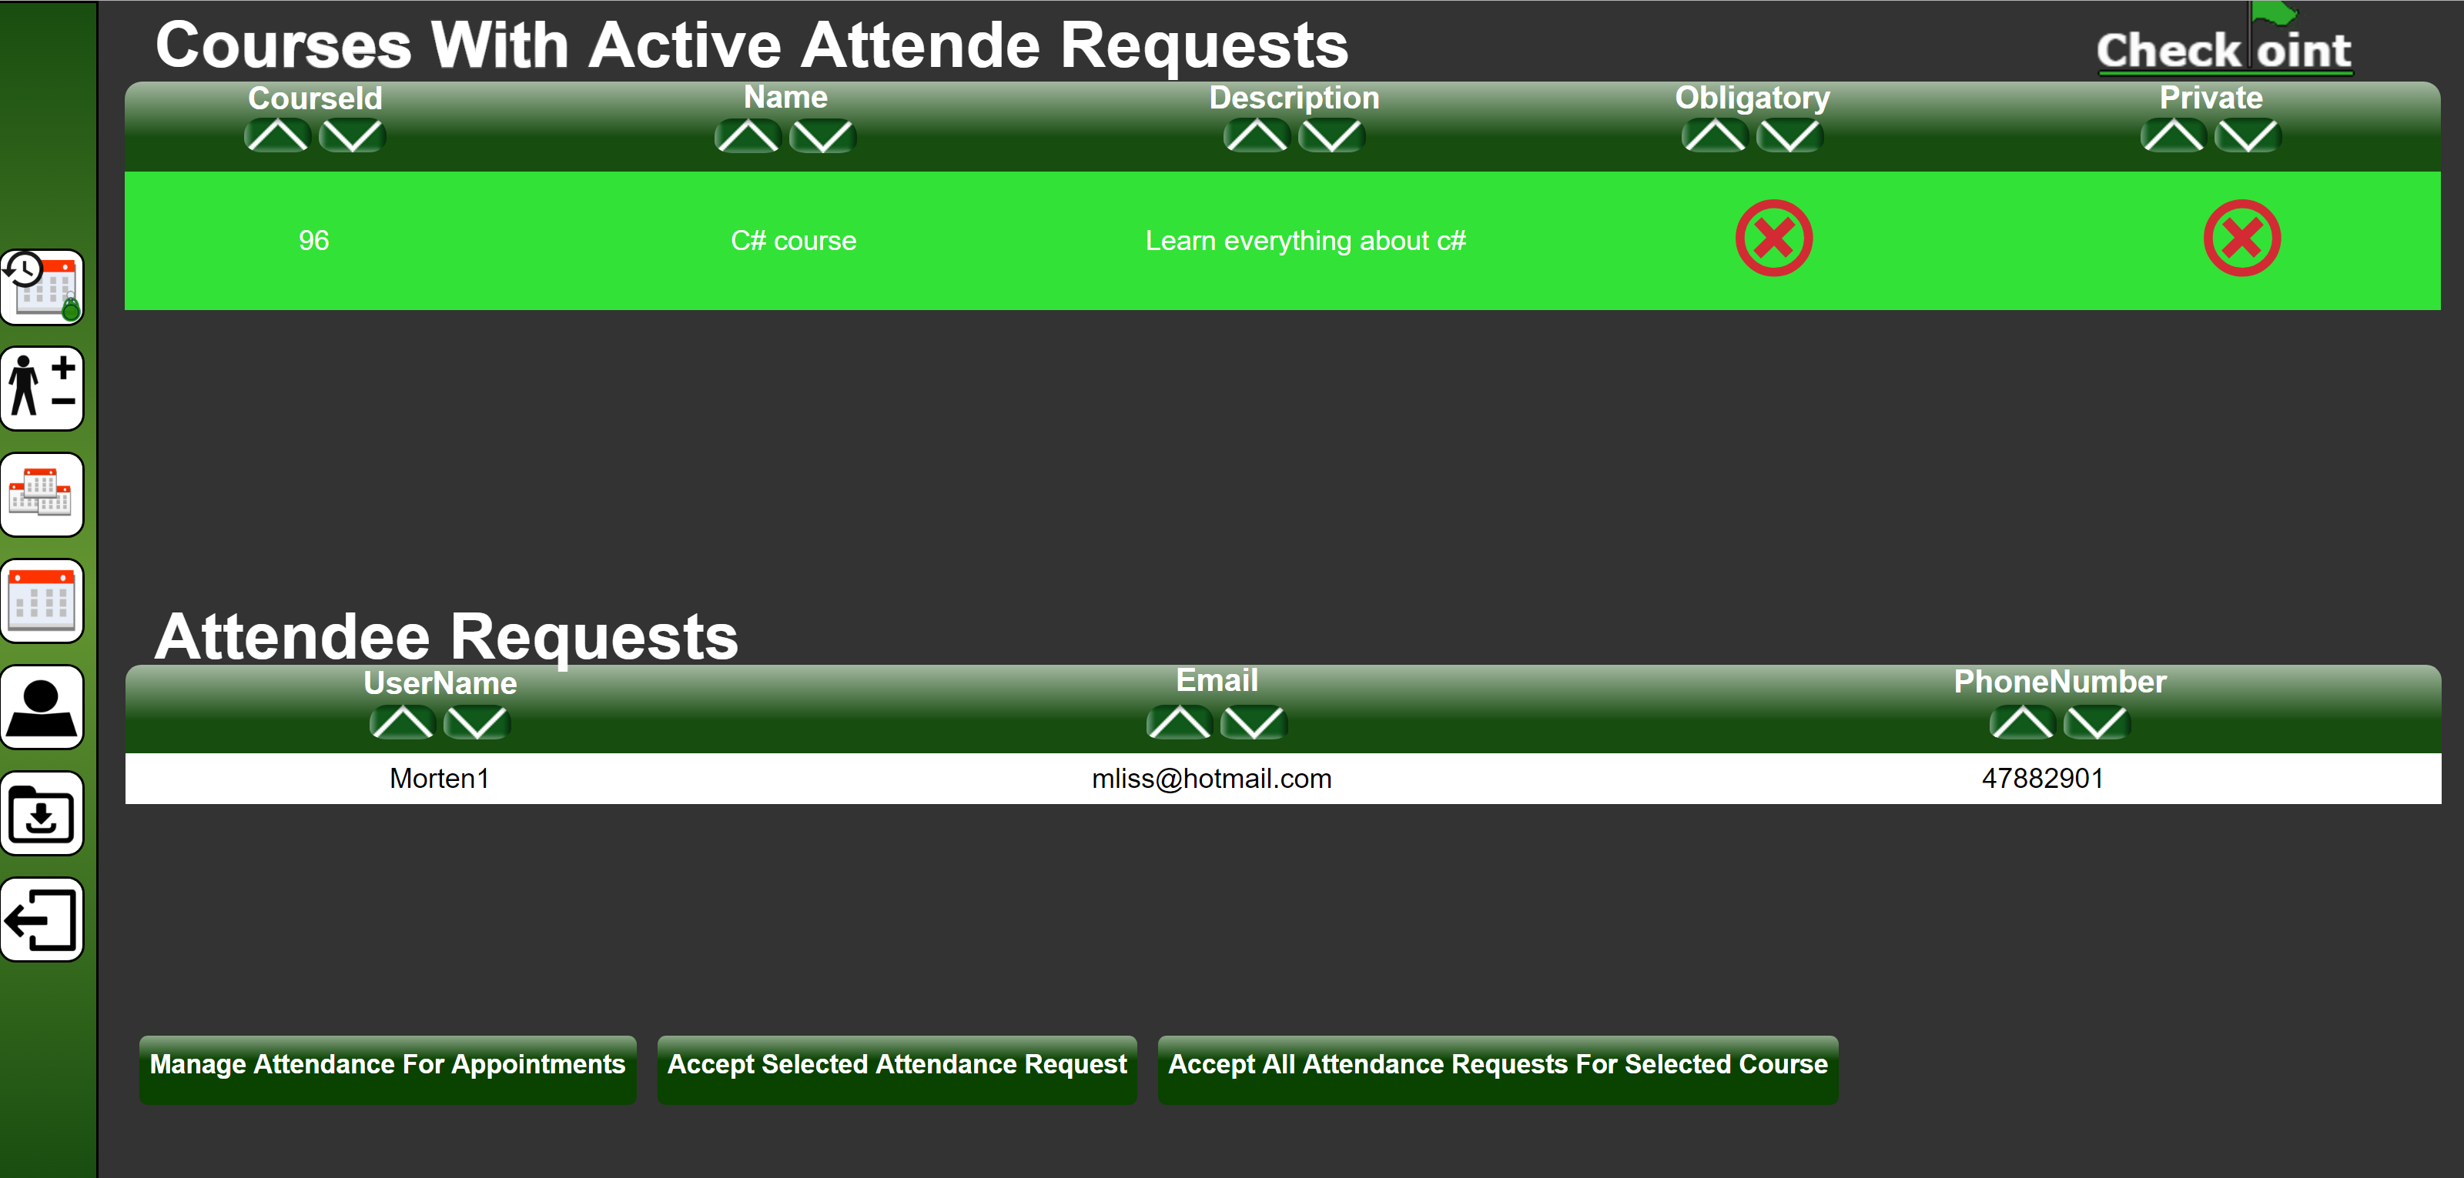

Figure 3‑10: Manage attendance for courses page, with selected course

### Manage Attendance For Appointments

By clicking the “Manage Attendance For Appointments” button as described in chapter 3.2.1 *Manage Attendance For Courses ,* you will be redirected to the “Manage Attendance For Appointments” web page as shown in *Figure 3‑11*.

On the “Manage Attendance For Appointments” web page shown in *Figure 3‑11*, you will get a detailed table view of all your appointments with active attendee requests. The appointments can be sorted by each column in the table, either by clicking the sort ascending button or sort descending button in the column shown in *Figure 3‑3.*

By clicking the “Manage Attendance For courses” button shown in *Figure 3‑11* and *Figure 3‑12,* you will be redirected to the “Manage Attendance For Courses” web page which is described in chapter **Error! Reference source not found.**.

By selecting a appointment in the table shown in *Figure 3‑9* a new table with the heading “Attendee Requests” will appears as shown in *Figure 3‑12.*

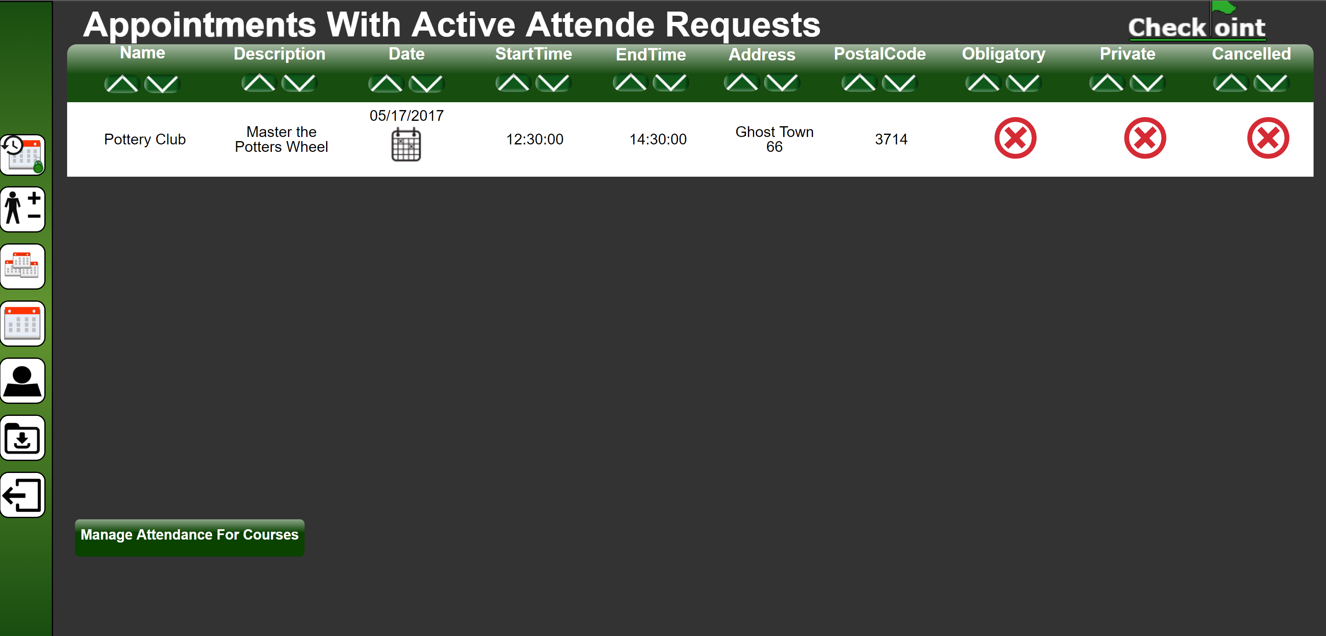

Figure 3‑11: Manage Attendance for Appointments page

By selecting a user from the “Attendee Request” table shown in *Figure 3‑12* and clicking the “Accept Selected Attendee Request” button shown in *Figure 3‑12,* you will make the selected user a attendee for that appointment. Now the user can attend your appointment!

By clicking the “Accept all Attendance Request For Selected Appointment” button shown in *Figure 3‑12,* you will make all the users in the “Attendee Requests” table attendees for the selected appointment. Now the users can attend your appointment!

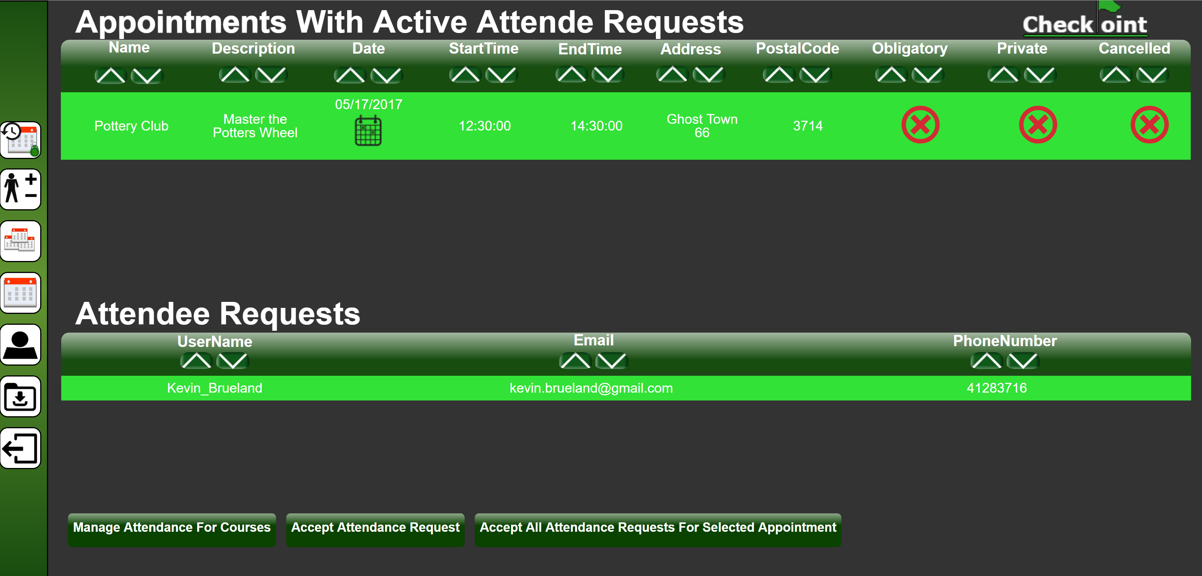

Figure 3‑12: Manage attendance for appointment page, appointment selected

## Courses

To access the “My Courses” web page, click the My courses icon on the navigation bar as illustrated in Figure 3‑13.

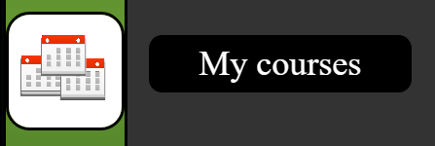

Figure 3‑13: My courses icon on the navigation bar

On this web page, which is illustrated in *Figure 3‑14*, you will get a detailed list view of all your courses. The courses can be sorted by each column in the table, either by clicking the sort ascending button or sort descending button in the column shown in Figure 3‑3.

You will also have the following options on the bottom of the web page illustrated  
 in *Figure 3‑14*:

*3.3.1 View Appointments*

*3.3.1 View Appointments*

By clicking the “View Appointments” button shown in *Figure 3‑14* you will be redirected to the “My appointments” web page which is described in chapter 3.1.

Create Course

*3.3.3 Manage Course*

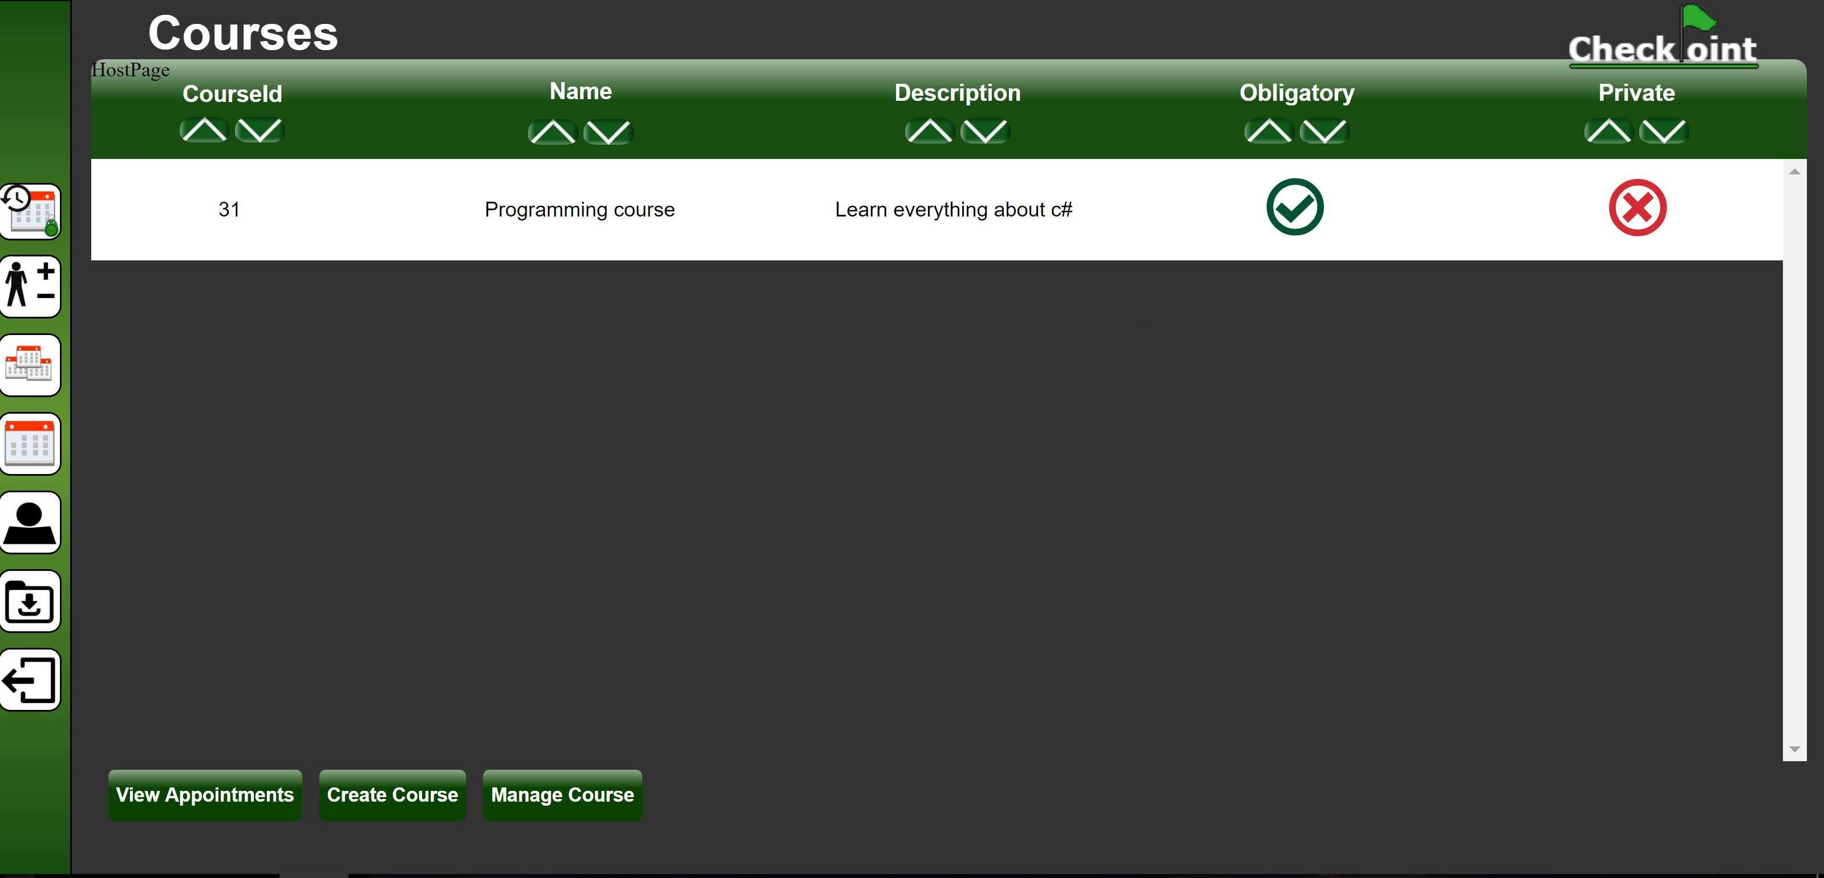

Figure 3‑14: My Courses web page

### View Appointments

By clicking the “View Appointments” button shown in *Figure 3‑14* you will be redirected to the “My appointments” web page which is described in chapter 3.1.

### Create Course

Create a new course by clicking the “Create Course” button shown in *Figure 3‑14*.  
This will redirect you to a web page where you can fill in the details of the new course, this is illustrated in *Figure 3‑15*.

When you create a course, you must choose if it should be:

* Obligatory, this will show users that it is an obligatory course.
* Private, only invited users can find and attend this course.

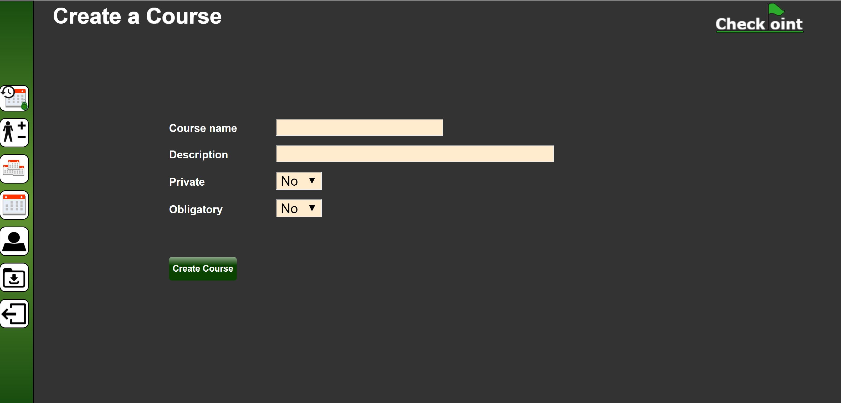

Figure 3‑15: Create course web page

### Manage Course

Manage a course by selecting an existing course from the list and clicking the “Manage Course” button shown in *Figure 3‑14*. This will redirect you to the “manage course” web page as illustrated in *Figure 3‑16.*

The top table (marked as 1 in red) in *Figure 3‑16* shows the course you are currently managing, while the table below (marked as 2 in red) shows all the current appointments in the course.

You will have the following button options at the bottom of the web page shown in *Figure 3‑16*:

*3.3.3.1 Update Course*

*3.3.3.2 Delete Course*

*3.3.3.3 Remove the selected appointment*

*3.3.3.4 Move the selected appointment to another course*

*3.3.3.5 Add another appointment to this course*

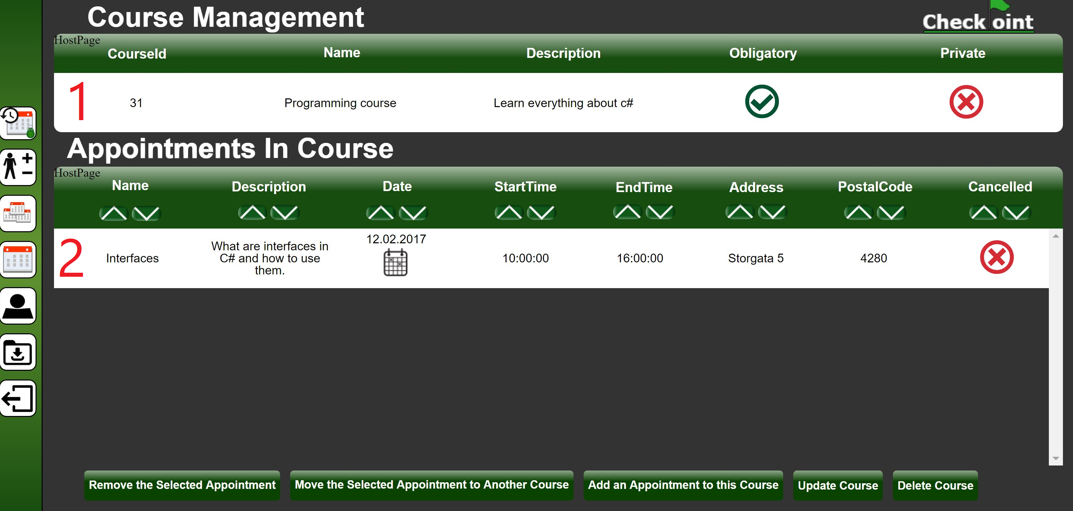

Figure 3‑16: Manage Course page

#### Update Course

Clicking the “Update Course” button shown in *Figure 3‑16* will redirect you to a web page as illustrated in *Figure 3‑17* ,where you can update the details of the course.

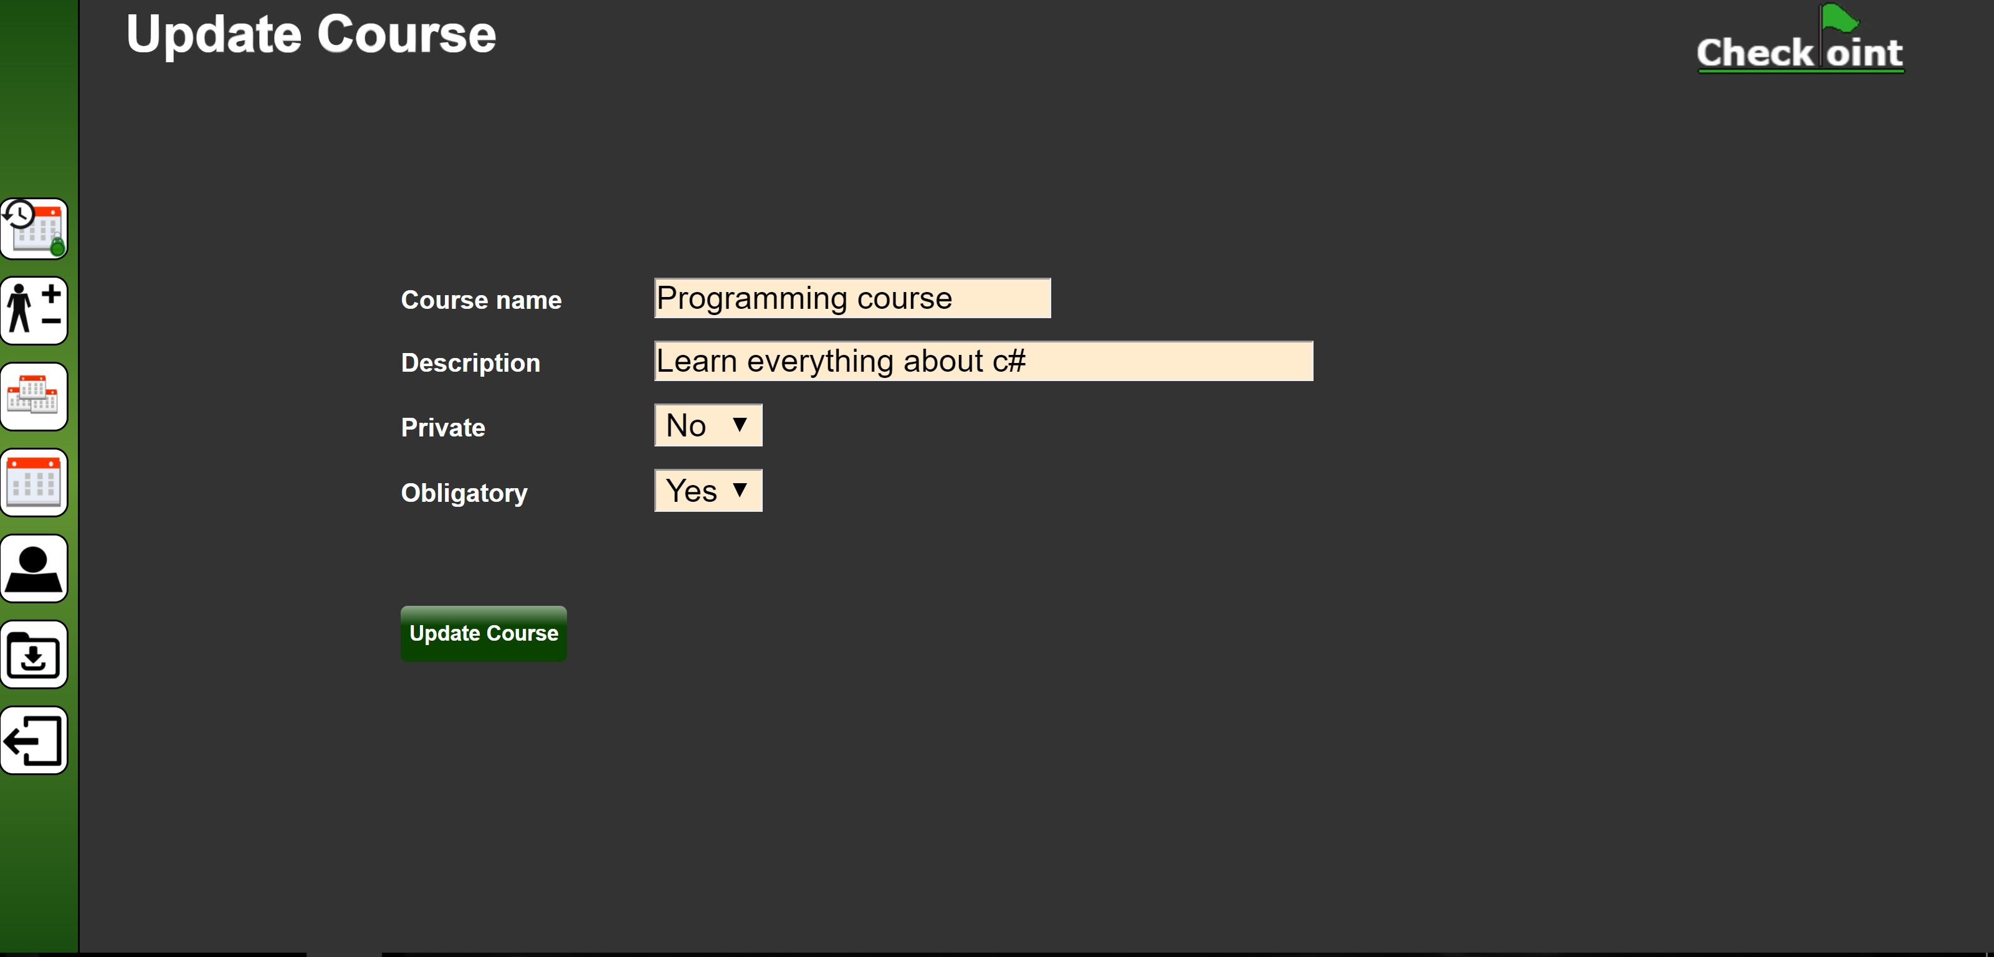

Figure 3‑17: Update course web page

#### Delete Course

Clicking the “Delete Course” button shown in *Figure 3‑16* will redirect you to the “delete course” web page as illustrated in *Figure 3‑18*, where you can confirm the deletion of the course. Deleting the course will also delete the appointments in the course, it can only be carried out if there are no attendees signed up for any of the appointments in the course.

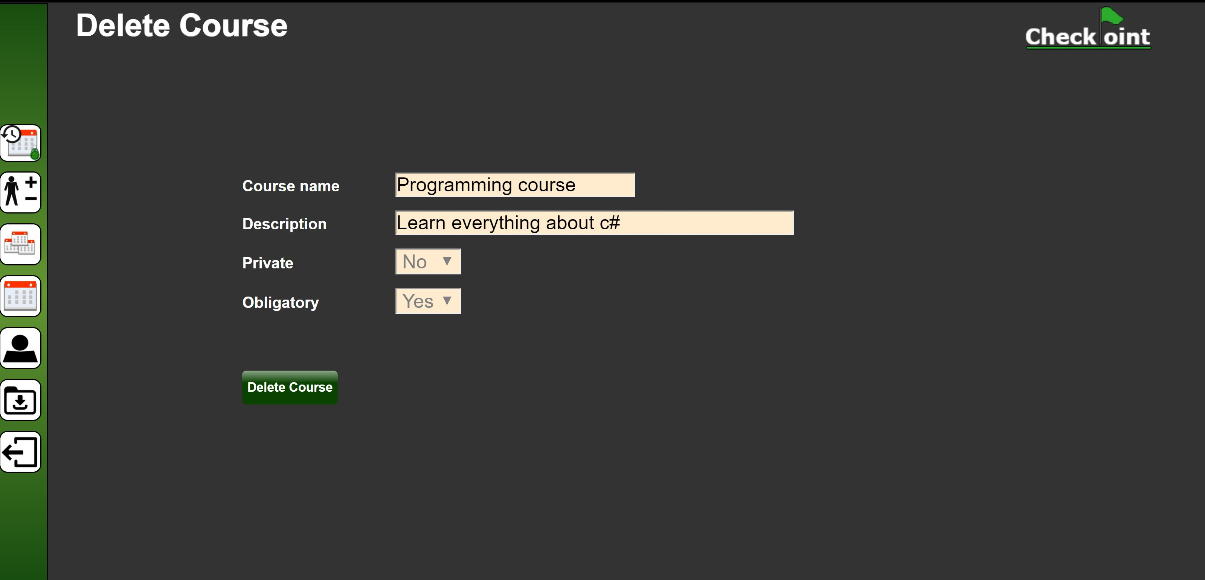

Figure 3‑18: Delete course web page

#### Remove the selected appointment

Select an appointment in the table and click “Remove the selected appointment” button shown in *Figure 3‑16* to remove it from the course.

#### Move the selected appointment to another course

Select an appointment in the list and click “Move the selected appointment to another course” button shown in *Figure 3‑16*. You will then get redirected to a new web page as illustrated in *Figure 3‑19* ,where you can select which of your courses the appointment will be moved to.



Figure 3‑19: Select course web page

#### Add another appointment to this course

By clicking “Add another appointment to this course” button shown in *Figure 3‑16*, you will be redirected to a web page as illustrated in *Figure 3‑20*. Here you can select an appointment from a table of all your appointments and add it to the course.

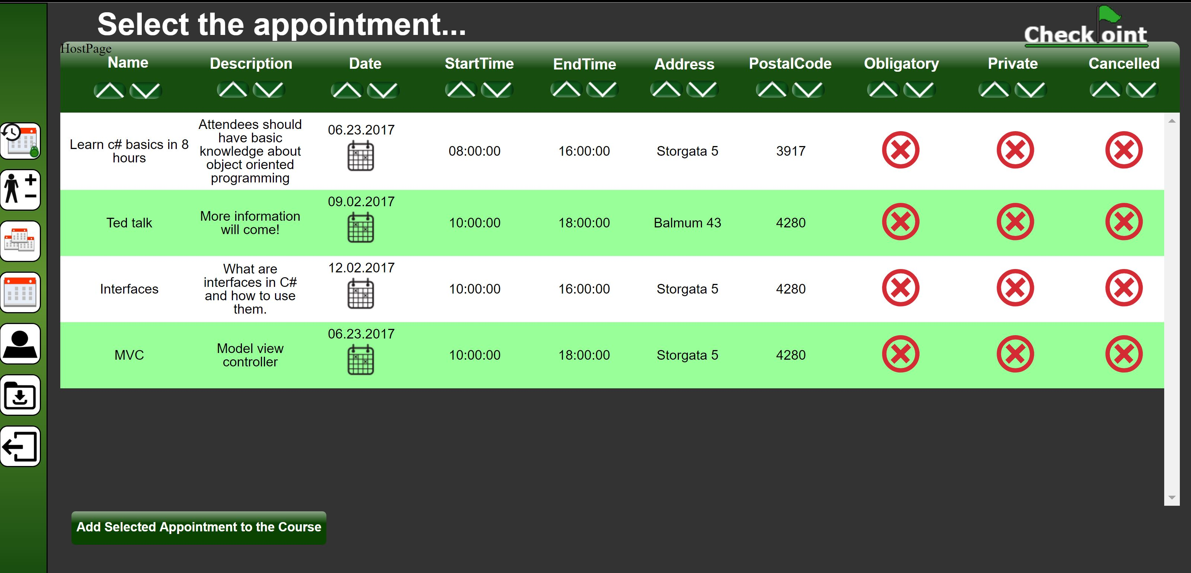

Figure 3‑20: Select appointment web page

## View Completed Appointments & Attendance History

By clicking the icon shown in *Figure 3‑21* on the navigation bar, you will be redirected to the “Completed appointments” web page.



Figure 3‑21: View Completed appointments & attendance history icon on navigation bar

On the “Completed appointments” web page, which is illustrated in Figure 3‑22, you will get a detailed table view of all your completed appointments. The appointments can be sorted by each column in the table, either by clicking the sort ascending button or sort descending button in the column shown in *Figure 3‑3*.

You will also have the option to select an appointment from the table and click the “View Attendance for Selected Appointment” at the bottom of the web page illustrated in *Figure 3‑22*. Doing this will redirect you to a web page described in chapter 3.4.1 *Appointment Attendance Records.*

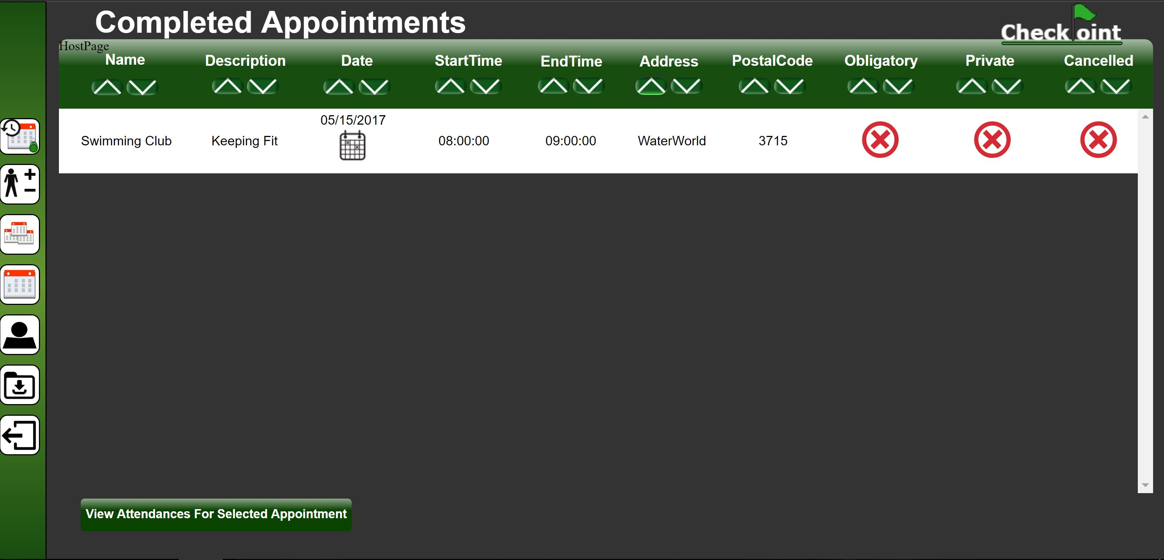

Figure 3‑22: Completed appointments web page

### Appointment Attendance Records

The top table (marked as 1 in red) in *Figure 3‑23* shows the appointment you are currently viewing attendance records for. The table below (marked as 2 in red) in *Figure 3‑23* shows all the users that has attended the appointment.

By clicking the “View Completed Appointments” button you will be redirected to the “Completed appointments” page described in chapter 3.4

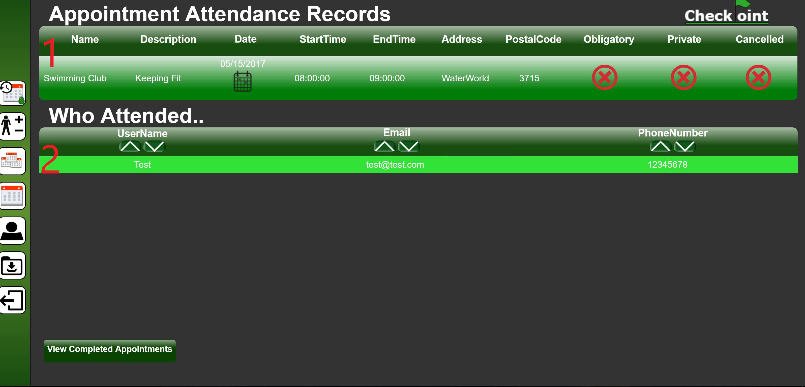

Figure 3‑23: Appointment attendance records web page

## Alter profile

By clicking the alter profile icon on the navigation bar as illustrated in *Figure 3‑24* you will get redirected to a web page where you can edit your own profile details.

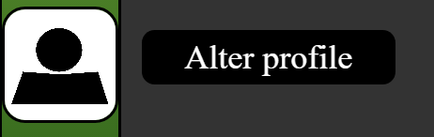

Figure 3‑24: Alter profile icon

## Log out

By clicking the Log out icon on the navigation bar as illustrated in *Figure 3‑25* you will be logged out of the CheckPoint system and redirected to the CheckPoint homepage.

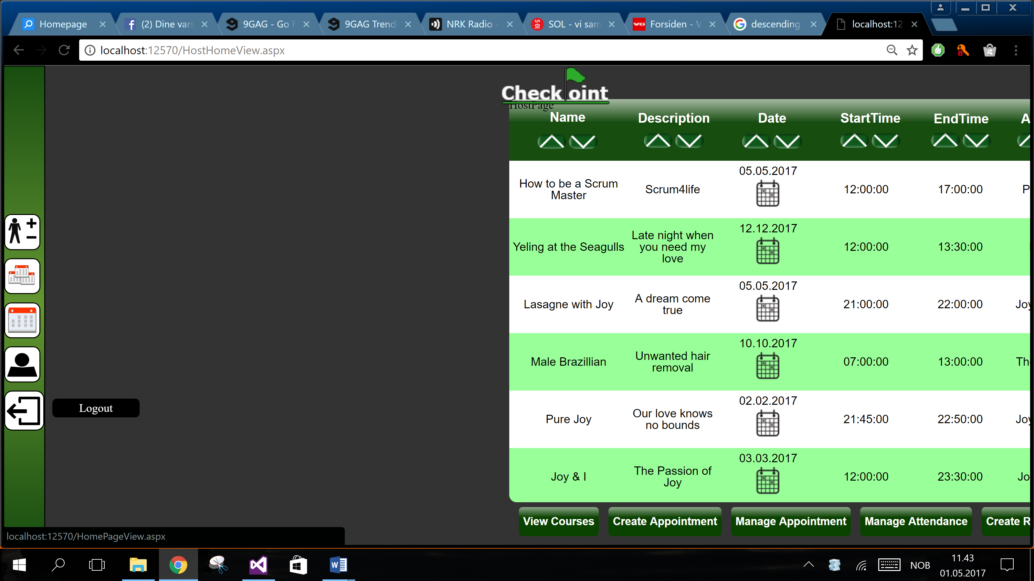

Figure 3‑25: Logout icon

# Troubleshooting

This chapter will address the most common problems you might experience when using the CheckPoint system. It will be presented in a Q&A style.

* This will be added if needed*

# Contact Us

Feel free to contact us should you need any information or if you are experiencing any problems with our product.

* *Support & General:*

+004746837573 (24/7)

* *Email:*

Support@CheckPoint.com